EXPERIMENT 7
7.1 PROGRAMS:
7.1.1//Inverted Star Pattern:
Ans: ALGORITHM:
Step 1: Start
Step 2: Input an integer value a
Step 3: Check the condition a > 0
Step 4: If the condition is true, print "*" repeated a times
Step 5: Decrease the value of a by 1
a = a − 1
Step 6: Go back to Step 3 and check the condition again
Step 7: If the condition a > 0 becomes false, stop the loop
Step 8: End
FLOWCHART:
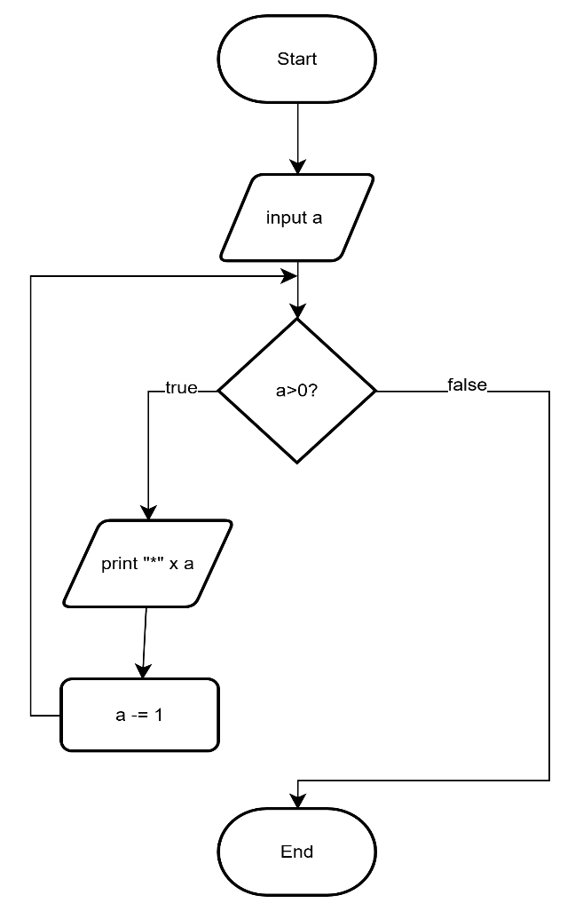

CODETANTRA:
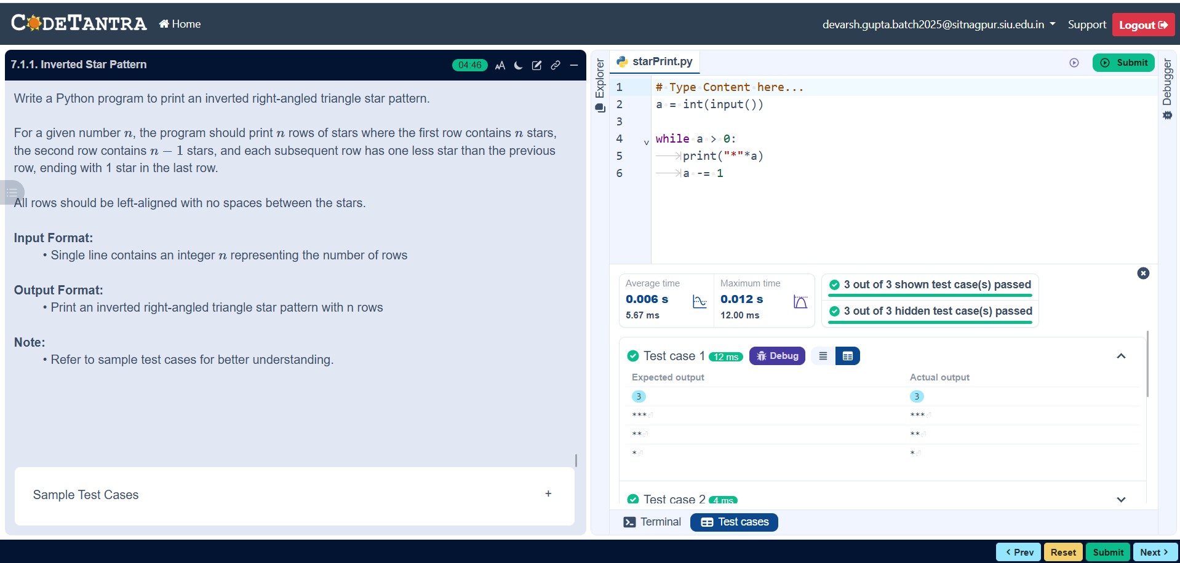

7.1.2//Possible combination of three digits
Ans: ALGORITHM:
Step 1: Start
Step 2: Input three values x, y, z
Step 3: Store them in a list
combi = [x, y, z]
Step 4: Set loop variable i = 0 to 2
Step 5: Set loop variable j = 0 to 2
Step 6: Set loop variable k = 0 to 2
Step 7: Check condition
i ≠ j AND i ≠ k AND j ≠ k
Step 8: If condition is true, print
combi[i] + combi[j] + combi[k]
Step 9: Repeat loops until all combinations are checked
Step 10: End
FLOWCHART:
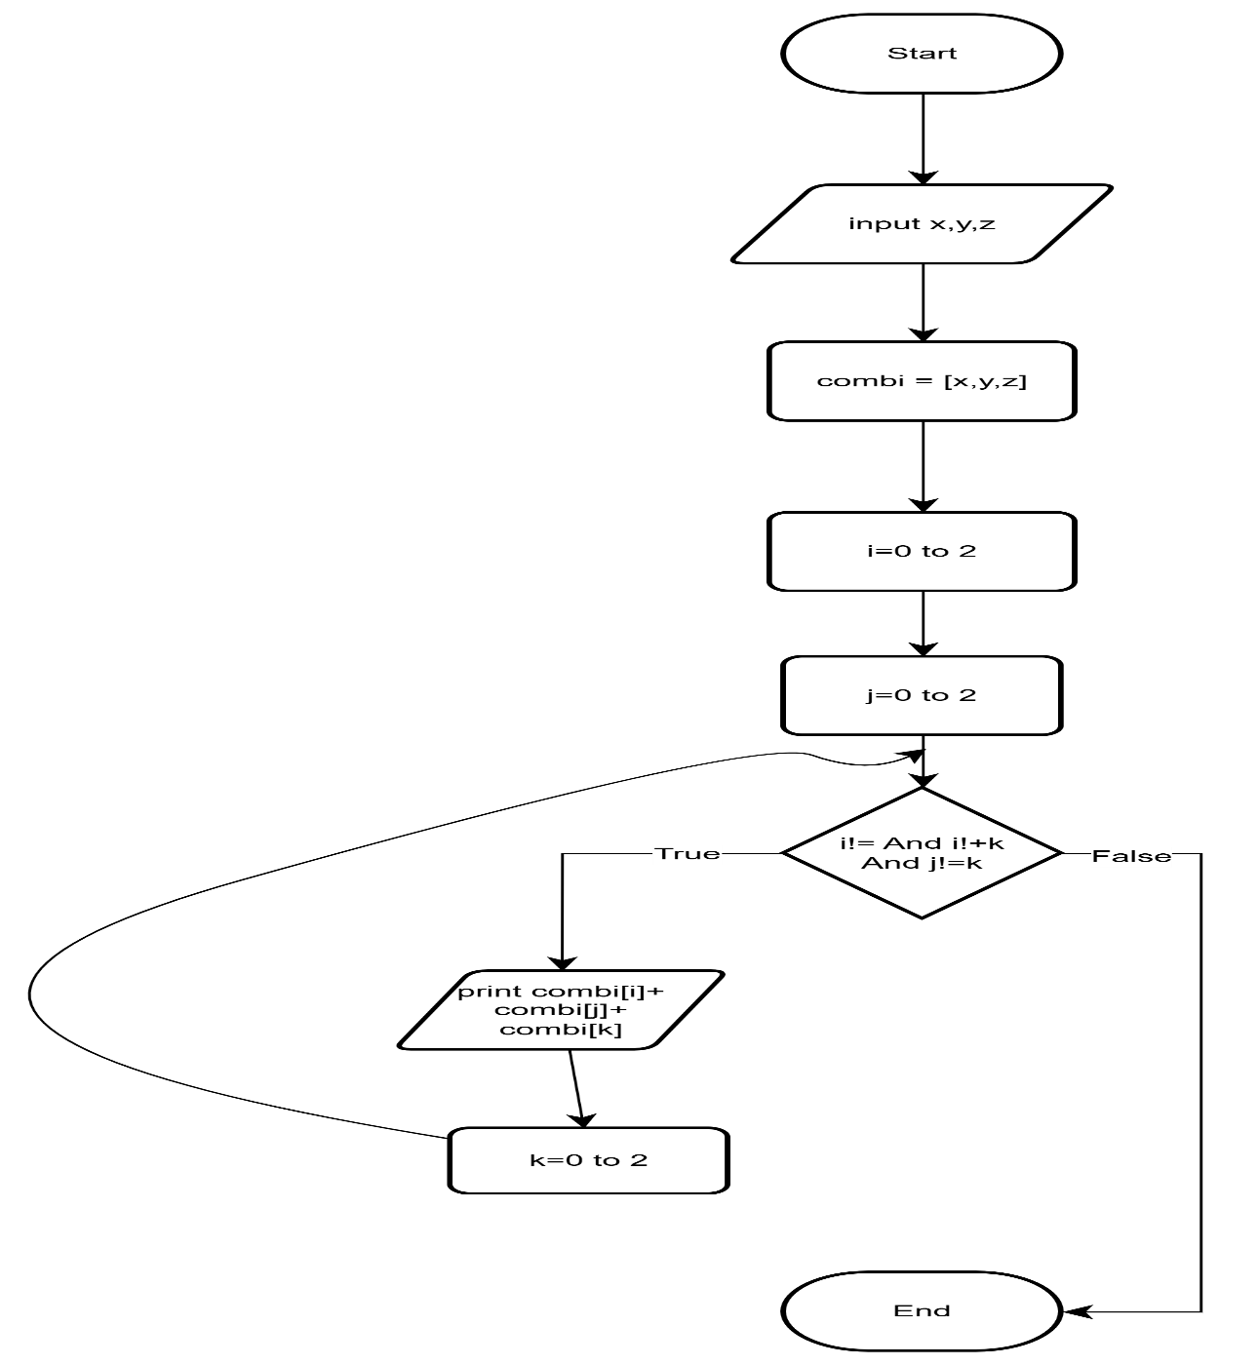

CODETANTRA:

